**Set Matrix Zeroes**

<https://leetcode.com/problems/set-matrix-zeroes/>

Given an m x n integer matrix matrix, if an element is 0, set its entire row and column to 0's.

You must do it [in place](https://en.wikipedia.org/wiki/In-place_algorithm).

**Example 1:**

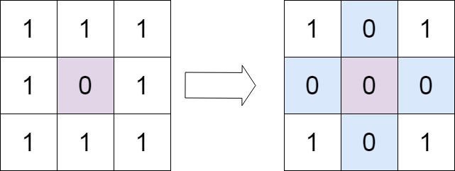

**Input:** matrix = [[1,1,1],[1,0,1],[1,1,1]]

**Output:** [[1,0,1],[0,0,0],[1,0,1]]

**Example 2:**

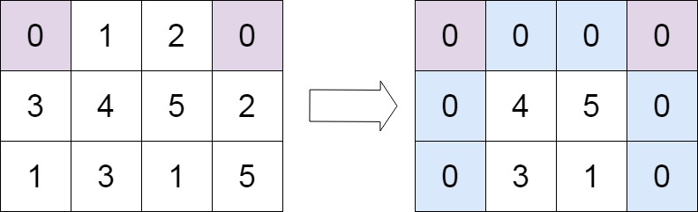

**Input:** matrix = [[0,1,2,0],[3,4,5,2],[1,3,1,5]]

**Output:** [[0,0,0,0],[0,4,5,0],[0,3,1,0]]

**Constraints:**

* m == matrix.length
* n == matrix[0].length
* 1 <= m, n <= 200
* -231 <= matrix[i][j] <= 231 - 1

**Follow up:**

* A straightforward solution using O(mn) space is probably a bad idea.
* A simple improvement uses O(m + n) space, but still not the best solution.
* Could you devise a constant space solution?